From: http://davidstockmanscontracorner.com/why-the-feds-doom-loop-will-take-the-us-economy-down-part-3/

Why The Fed's Doom-Loop Will Take The US Economy Down, Part 3
By David Stockman. Posted On Monday, February 25th, 2019
Since the Fed is no longer focussed on Money at all, it has an ill-disguised Achilles Heel. Namely, without its make pretend pursuit of Economy, it's real function would be laid bare for all to see.
That is, it is essentially the handmaid of Wall Street and the agency which fosters the latter's massive games of speculation. It does so via its modus operandi of falsifying money market rates, thereby subsidizing the carry trades, and via the epic financial fraud implicit in its massive balance sheet purchases from Wall Street dealers, which are funded with counterfeit credits.
And that's not our opinion---it's the official position of one of the Fed's core insiders, St. Louis Fed President James Bullard. The latter wrote a 1990 PhD on "Time-Varying Parameters and Nonconvergence to Rational Expectations under Least Squares Learning" and has been on the Fed's payroll ever since.
That is, he has never contributed a single dime of value-added to the US economy during his entire career, but has been so infected with Keynesian group-think that he now avers the job of the Fed is to process the orders it gets from Wall Street:
“We did get a bad reaction in financial markets. I think the market started to think we were too hawkish, might cause a recession…I think all of this weighed on the committee and got people to change their thinking….the normalization process in the United States is coming to an end”.
Perversely, of course, he is right about causing a recession. The main street economy is now at the mercy of the C-suites of corporate America, which have been turned into stock trading rooms and financial engineering joints by the speculative finance the Fed has unleashed on Wall Street.
Accordingly, if the Fed lets stock markets "price-in" the dismal reality of the debt-encumbered main street and world economy, collapsing stock options will trigger another C-suite driven recession in the form of sweeping restructuring plans, asset write-offs and violent liquidations of inventories and jobs.
So as if stuck to some kind of financial tar-baby, the Fed hangs on for dear life, predictably and capriciously countermanding every incipient equity market sell-0ff---as in its post-Christmas Eve capitulation---in the insensible hope that the day of reckoning can be deferred indefinitely.
What we are saying is that in the era of Peak Debt on main street and internet enabled global trade dominated by
the China Price for goods and
the India Price for services,
the Fed has neither the competence nor tools to do anything about Economy. The so-called Humphrey-Hawkins inflation, employment and interest rate mandates are pure legislative nostalgia at best; and more aptly, a misbegotten invitation to pursue an economic Mission Impossible.
So like lunatics professing to be warding off marauding elephant herds on Independence Avenue, the FOMC simply pegs interest rates and massively monetizes public debts and other securities on the wholly academic theory that its helping improve the performance of Economy---- when it is actually doing little more than fostering rampant speculation and ever-inflating financial assets within the canyons of Wall Street.
Quite naturally and inevitably, of course, asset inflation cycles reach their own asymptote ---as in 2000, 2007 and again in 2018---and then the central bank throws common sense and empirical facts to the winds, making up ever more implausible excuses for capitulating to the petulant day traders and robo-machines of Wall Street.
As Sven Henrich so cogently observed:
Market performance and economic performance have become so intertwined that the Fed’s primary mandate, admitted or not, involves preventing or minimizing market drops. A crash would bring about a recession and hence Bernanke stepped in again in 2011 and 2012 following the initial QE1 program, hence why Janet Yellen paused rate hikes in February 2016, hence why Powell stopped rate hikes now. All for the same reason, all at the same time: Coinciding with dropping markets.
These bouts of capitulation like the recent Powell Pivot, of course, involve increasingly desperate and nonsensical rationalizations.
For instance, the Eccles Building has recently manufactured the claim from wholecloth that the financial system now needs approximately $1.2 trillion of excess reserves to function properly, which in turn, implies that QT should be abruptly terminated after its balance sheet has shrunk only modestly to @ $3.6 trillion.
The fact is, until the Bernanke panicked in September 2008 about the phony Depression 2.0 hobgoblin there had never been material excess bank reserves, while total reserves on deposit with the Fed had rarely reached $40 billion in modern times, as highlighted by the nearly invisible light blue line prior to 2008 in the chart below.
Yet annual real GDP growth was reasonably buoyant in the 1980s and 1990s, notwithstanding the absence of excess reserves in the banking system. That is to say, the claim that most of the aberrant eruption in reserves is necessary f0r healthy Economy is absolute Eccles Building malarkey.
Excess Bank Reserves Have Zero Correlation With Annual Real GDP Growth
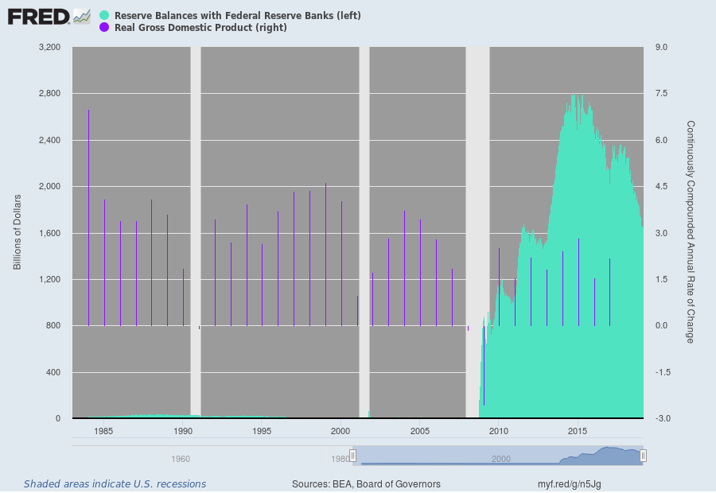
Moreover, the new claim about preserving a swollen Fed balance sheet and $1.2 trillion of excess reserves in the banking system contradicts practically everything Fed heads have said about its hideously swollen balance sheets ever since the allegedly temporary expedient of QE and massive balance sheet expansion was adopted after the financial crisis.
Indeed, in his panic abandonment of "automatic pilot" after the Christmas Eve sell-off, Powell essentially exposed Ben Bernanke's original Big Lie for all to see.
Back in October 2012, in fact, when Powell was already a member of the FOMC, the Bernank solemnly promised that nobody in the Eccles Building was embracing the ancient sin of monetizing the public debt:
“Monetizing the debt means using money creation as a permanent source of financing for government spending. In contrast, we are acquiring Treasury securities on the open market and only on a temporary basis, with the goal of supporting the economic recovery through lower interest rates. At the appropriate time, the Federal Reserve will gradually sell these securities or let them mature, as needed, to return its balance sheet to a more normal size.”
Needless to say, if that statement had been honest, the Bernank would have added that when we unwind the massive jolt of financial asset inflation we are injecting into the bond pits, an equal and opposite reaction will occur. Upon draining the $3.5 trillion of cash we have dumped into the bond pits, our Big Fat Bid will become a Big Fat Offer, taking financial asset prices plunging into the drink with them.
By the time the Fed got around to attempting the balance sheet shrinkage that Bernanke had promised, however, the Fed heads had already invented a totally new theory----one that essentially repealed the laws of financial symmetry.
For mysterious reasons they did not explain, Fed speakers led by Janet Yellen herself insisted that QT would be a non-event. Yellen compared the Fed promise to normalize and shrink its balance sheet to watching "paint dry on a wall"; and the Fed's guidance upon the commencement of QT at $10 billion per month in October 2017 even went so far as to say it would not even comment on the matter in its post-meeting statements in the future because the QT process would be so automatic and non-consequential.
One of the loudest voices for the purported asymmetry of QE and QT was the aforementioned modeler of monetary puzzle palaces, James Bullard.
Yet after the Christmas Eve plunge, he abandoned the theory like a hot potato---just as his counseled capitulation to Wall Street on every other downdraft during recent years. As the King Report noted this AM:
St. Louis Fed President Bullard argues that the case for relatively small macroeconomic effects of balance sheet reduction is more accurate
The above story evinces why the Fed is held in such low regard. Numerous Fed officials over the past few months, in order to boost stocks, have stridently announced that the Fed balance sheet runoff should end. If the Fed’s balance sheet has a relatively small macroeconomic effect, then Fed officials are primarily concerned about the Fed balance sheet’s effect on the stock market.
Needless to say, this is just one of endless examples of making it up as they fly by the seat of their pants, desperately hoping to keep the stock market levitated. The recent gumming about the imaginary and truly idiotic notion of r-star, or the neutral rate of interest, is even more ludicrous.
Recently, New York Fed President John Williams, another Fed lifer, actually argued that since r-star is allegedly now much lower than its historical value and stands at about 2.0%, this completely made up interest rate target should be accompanied by a higher than historical 2.00% target for inflation.
As we indicated in Part 2, that implies negative real money market rates virtually indefinitely because apparently inflationary undershoots are economically fatal, meaning that our monetary central planners dare not allow bygones to be bygones!
That's right. John William's most recent inflation gibberish:
Mr. Williams, a leading advocate of the second approach, offered a simple example in a speech last fall. Imagine the central bank succeeds at keeping inflation at 2% during periods when the economy is expanding and interest rates aren’t constrained by being at zero. But 20% of the time, when the economy is in recession and interest rates have been cut to zero, inflation averages 1%.
The result is that inflation over the cycle averages 1.8%, below the desired 2% target. In turn, this pulls down expectations of future inflation, which makes monetary policy even less effective. In this environment, “monetary policy is always swimming upstream, fighting a current of too-low inflation expectations,” said Mr. Williams.
It doesn’t sound like much of a change, but it is an important one because you’re no longer following a ‘bygones’ policy,” said William Dudley, who was New York Fed president from 2009 until last June. “If you miss below the 2% target, you’re going to try to make it up, and the Fed has not really said that up to now.”
Needless to say, all the Fed heads are now clacking about "bygones" meaning that it amounts to the worst kind of groupthink imaginable.
As we will address in Part 4, exactly how does too little cumulative inflation as measured by the PCE deflator have anything to do with real world consumer propensities for purchase of autos, energy, food, restaurant services, computer equipment and devices or anything else---all of which have radically differently price trends and cycles than the index average as a whole?
The fact is, we are dealing here with the fallacy of the abstract aggregate. Its application to the misbegotten practice of inflation targeting by central bankers is so threadbare as to be truly laughable.
Stated differently, they are now so desperate to appease the Wall Street speculators that they have succumbed to pure rubbish in the name of Economy.

